Arc of Tippecanoe Bingo Night

 | B | I | N | G | O
 |  | Arrowhead | 2331 | Brothers Dr. | Lafayette
 | When: |  | August 25 | 2017 | 6pm-8pm
 | What: | Dinner |  | Bingo | Prizes
 | Meal: | Catered | Nacho |  | Drinks
 | Cost: | $7.00 | Per Person | Staff &

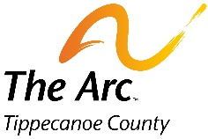
RSVP By August 21 to reserve your spot:
rsvparcoftippecanoe@yahoo.com

