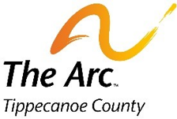

SING WITH THE ARC

Join us for a night of music and dancing. Show off your vocal skills and impress the judges for a chance at winning the first ever Tippecanoe Arc Lip Sync contest.
When: Saturday May 1, 2021 6:00pm – 8:00pm
Where: Bauer Center 330 Fountain St Lafayette, IN
Cost $5.00 per person
This event will be limited to the first 50 members to RSVP.
RSVP to rsvp@arcoftippecanoe.org by April 28 at 5pm to
Ensure your spot in this event.

